Database Technologies Lab Sheet — 3
Course Code: MCA105P
Database, Tables & Advance User Accounts —
50 Practice ProblemsSec ones: A – Easy (20) ·B – Medium (20) ·C – Hard (10)
Coverage: DCL and its types

-- 1. DATABASE & SCHEMA CREATION
CREATE DATABASE IF NOT EXISTS company_db;
USE company_db;

CREATE TABLE departments (
dept_id INT PRIMARY KEY,
dept_name VARCHAR(50) NOT NULL,
location VARCHAR(50),
budget DECIMAL(12,2)
) ENGINE=InnoDB;

CREATE TABLE employees (
emp_id INT PRIMARY KEY,
first_name VARCHAR(50),
last_name VARCHAR(50),
dept_id INT,
salary DECIMAL(10,2),
hire_date DATE,
is_active BOOLEAN,
FOREIGN KEY (dept_id) REFERENCES departments(dept_id)
) ENGINE=InnoDB;

CREATE TABLE orders (
order_id INT PRIMARY KEY,
customer_name VARCHAR(100),
order_date DATE,
total_amount DECIMAL(10,2),
status VARCHAR(20)
) ENGINE=InnoDB;

-- ==========================================================
-- 2. ADVANCE USER CREATION WITH VARYING PRIVILEGE LEVELS
-- ==========================================================

-- Level 0: Unprivileged Accounts (No Grants yet)
CREATE USER IF NOT EXISTS 'john'@'localhost' IDENTIFIED BY 'JohnPass2026!';
CREATE USER IF NOT EXISTS 'alice'@'localhost' IDENTIFIED BY 'AlicePass2026!';
CREATE USER IF NOT EXISTS 'intern_user'@'localhost' IDENTIFIED BY 'InternPass2026!';
CREATE USER IF NOT EXISTS 'temp_user'@'localhost' IDENTIFIED BY 'TempPass2026!';
CREATE USER IF NOT EXISTS 'sec_user'@'localhost' IDENTIFIED BY 'SecPass2026!';
CREATE USER IF NOT EXISTS 'admin_user'@'%' IDENTIFIED BY 'AdminPass2026!';

-- Level 1: Read-Only User Accounts
CREATE USER IF NOT EXISTS 'auditor'@'localhost' IDENTIFIED BY 'AuditPass2026!';
GRANT SELECT ON company_db.* TO 'auditor'@'localhost';

CREATE USER IF NOT EXISTS 'analyst'@'localhost' IDENTIFIED BY 'AnalystPass2026!';
GRANT SELECT ON company_db.* TO 'analyst'@'localhost';

-- Level 2: Operational / Departmental Users
CREATE USER IF NOT EXISTS 'manager'@'localhost' IDENTIFIED BY 'MgrPass2026!';
GRANT SELECT, INSERT, UPDATE ON company_db.orders TO 'manager'@'localhost';

CREATE USER IF NOT EXISTS 'dev_user'@'localhost' IDENTIFIED BY 'DevPass2026!';
GRANT SELECT, INSERT, UPDATE ON company_db.* TO 'dev_user'@'localhost';

CREATE USER IF NOT EXISTS 'hr_assistant'@'localhost' IDENTIFIED BY 'HrPass2026!';
GRANT SELECT, UPDATE ON company_db.employees TO 'hr_assistant'@'localhost';

CREATE USER IF NOT EXISTS 'finance_user'@'localhost' IDENTIFIED BY 'FinPass2026!';
GRANT SELECT, UPDATE ON company_db.departments TO 'finance_user'@'localhost';

-- Level 3: Lead & Administrative Users (With Delegation Rights)
CREATE USER IF NOT EXISTS 'team_lead'@'localhost' IDENTIFIED BY 'LeadPass2026!';
GRANT SELECT, INSERT ON company_db.* TO 'team_lead'@'localhost' WITH GRANT OPTION;

FLUSH PRIVILEGES;
INSERT INTO departments (dept_id, dept_name, location, budget) VALUES
(10, 'Engineering', 'Building A', 500000.00),
(20, 'Marketing', 'Building B', 200000.00),
(30, 'Human Resources', 'Building A', 150000.00),
(40, 'Finance', 'Building C', 350000.00),
(50, 'Research', 'Building D', 600000.00);

INSERT INTO employees (emp_id, first_name, last_name, dept_id, salary, hire_date, is_active) VALUES
(101, 'Alice', 'Smith', 10, 75000.00, '2021-03-15', TRUE),
(102, 'Bob', 'Johnson', 20, 52000.00, '2022-06-01', TRUE),
(103, 'Charlie', 'Brown', 10, 82000.00, '2019-11-20', TRUE),
(104, 'Diana', 'Prince', 30, 48000.00, '2023-01-10', FALSE),
(105, 'Evan', 'Wright', 20, 61000.00, '2020-08-05', TRUE);

INSERT INTO employees (emp_id, first_name, last_name, dept_id, salary, hire_date, is_active) VALUES
(101, 'Alice', 'Smith', 10, 75000.00, '2021-03-15', TRUE),
(102, 'Bob', 'Johnson', 20, 52000.00, '2022-06-01', TRUE),
(103, 'Charlie', 'Brown', 10, 82000.00, '2019-11-20', TRUE),
(104, 'Diana', 'Prince', 30, 48000.00, '2023-01-10', FALSE),
(105, 'Evan', 'Wright', 20, 61000.00, '2020-08-05', TRUE);

-- ==========================================================
-- SECTION A: EASY LEVEL PROBLEMS (Q01 - Q10)
-- ==========================================================

-- Q01. Grant SELECT permission on company_db to pre-created user 'john'@'localhost'.
GRANT SELECT ON company_db.* TO 'john'@'localhost';

-- Q02. Grant SELECT and INSERT permissions on company_db.employees to 'alice'@'localhost'.
GRANT SELECT, INSERT ON company_db.employees TO 'alice'@'localhost';

-- Q03. Revoke INSERT privilege on company_db.employees from user 'alice'@'localhost'.
REVOKE INSERT ON company_db.employees FROM 'alice'@'localhost';

-- Q04. Explicit Transaction Start for 'dev_user'
START TRANSACTION;

-- Q05. Permanent COMMIT after inserting Department 60
INSERT INTO departments (dept_id, dept_name, location, budget) VALUES (60, 'Quality Assurance', 'Building C', 300000.00);
COMMIT;

-- Q06. Transaction ROLLBACK for 'hr_assistant'
START TRANSACTION;
DELETE FROM employees WHERE emp_id = 105;
ROLLBACK;

-- Q07. Creating SAVEPOINT
START TRANSACTION;
INSERT INTO departments (dept_id, dept_name, location, budget) VALUES (70, 'Legal', 'Building D', 150000.00);
SAVEPOINT sp_before_update;

-- Q08. Global Admin Grant for 'admin_user'@'%'
-- GRANT ALL PRIVILEGES ON *.* TO 'admin_user'@'%' WITH GRANT OPTION;

-- Q09. Refresh Privilege Tables
FLUSH PRIVILEGES;

-- Q10. Revoking ALL Privileges from 'intern_user'@'localhost'
REVOKE ALL PRIVILEGES, GRANT OPTION FROM 'intern_user'@'localhost';

-- ==========================================================
-- SECTION B: MEDIUM LEVEL PROBLEMS (Q11 - Q20)
-- ==========================================================

-- Q11. [DCL - User Provisioning & Granting]
GRANT DELETE ON company_db.orders TO 'dev_user'@'localhost';

-- Q12. [TCL - Multi-Step Savepoint Workflow]
START TRANSACTION;
UPDATE company_db.employees SET salary = 80000.00 WHERE emp_id = 101;
SAVEPOINT sp_first;
UPDATE company_db.employees SET salary = 95000.00 WHERE emp_id = 102;
ROLLBACK TO SAVEPOINT sp_first;
COMMIT;

-- Q13. [DCL - Selective Privilege Revocation]
REVOKE UPDATE ON company_db.employees FROM 'hr_assistant'@'localhost';

-- Q14. [TCL - Read-Only Transaction Mode]
SET TRANSACTION READ ONLY;
START TRANSACTION;
SELECT * FROM company_db.employees;
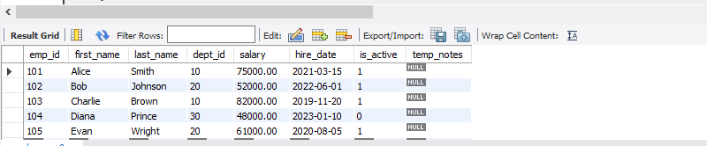

COMMIT;

-- Q15. [TCL - Implicit Commit via DDL Hazard]
START TRANSACTION;
UPDATE company_db.employees SET salary = 85000.00 WHERE emp_id = 101;
-- Executing DDL causes implicit commit:
ALTER TABLE company_db.employees ADD COLUMN temp_notes VARCHAR(100);

-- Q16. [TCL - Financial Budget Transfer]
START TRANSACTION;
UPDATE company_db.departments SET budget = budget - 10000.00 WHERE dept_id = 10;
UPDATE company_db.departments SET budget = budget + 10000.00 WHERE dept_id = 20;
COMMIT;

-- Q17. [DCL - Delegation Rights Audit]
SHOW GRANTS FOR 'team_lead'@'localhost';
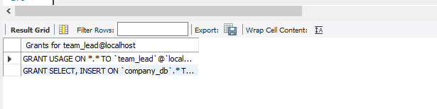

-- Q18. [DCL - Revoking Delegation Rights]
REVOKE GRANT OPTION ON company_db.* FROM 'team_lead'@'localhost';

-- Q19. [TCL - Order Status Workflow Rollback]
START TRANSACTION;
UPDATE company_db.orders SET status = 'Shipped' WHERE order_id = 5002;
-- Condition check: order 5002 total_amount is 450.00 (< 500)
ROLLBACK;

-- Q20. [DCL - Role-Based Access Control (RBAC)]
CREATE ROLE IF NOT EXISTS 'reporter_role';
GRANT SELECT ON company_db.* TO 'reporter_role';
GRANT 'reporter_role' TO 'analyst'@'localhost';
SET DEFAULT ROLE 'reporter_role' TO 'analyst'@'localhost';

-- ==========================================================
-- SECTION C: HARD LEVEL PROBLEMS (Q21 - Q30)
-- ==========================================================

-- Q21. [TCL - Conditional Multi-Table Transaction]
START TRANSACTION;
UPDATE company_db.employees SET salary = salary * 1.15 WHERE dept_id = 10;
SAVEPOINT sp_salary_done;
UPDATE company_db.departments SET budget
-- Q22. [TCL - Exclusive Pessimistic Locking]
START TRANSACTION;
SELECT * FROM company_db.employees WHERE emp_id = 101 FOR UPDATE;
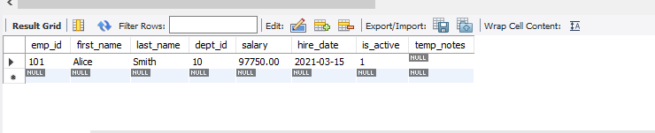

UPDATE company_db.employees SET salary = 88000.00 WHERE emp_id = 101;
COMMIT;

-- Q23. [TCL - Shared Read Locking]
START TRANSACTION;
SELECT * FROM company_db.departments WHERE dept_id = 10 FOR SHARE;
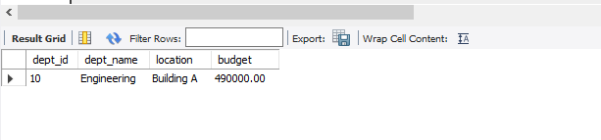

COMMIT;

-- Q24. [DCL - Account Resource Throttling]
ALTER USER 'auditor'@'localhost' WITH MAX_QUERIES_PER_HOUR 100 MAX_USER_CONNECTIONS 2;

-- Q25. [TCL - Order Cancellation Sync Workflow]
START TRANSACTION;
UPDATE company_db.orders SET status = 'Cancelled' WHERE order_id = 5002;
UPDATE company_db.departments SET budget = budget + 450.00 WHERE dept_id = 20;
COMMIT;

-- Q26. [DCL - Role Inheritance Hierarchy]
CREATE ROLE IF NOT EXISTS 'read_role', 'write_role', 'admin_role';
GRANT 'read_role', 'write_role' TO 'admin_role';
CREATE USER IF NOT EXISTS 'super_dev'@'localhost' IDENTIFIED BY 'SuperDevPass2026!';
GRANT 'admin_role' TO 'super_dev'@'localhost';

-- Q27. [TCL - Deadlock Handling Simulation]
START TRANSACTION;
UPDATE company_db.employees SET salary = salary + 1000 WHERE emp_id = 101;
COMMIT;

-- Q28. [DCL - Encrypted Transport (TLS/SSL) Enforcement]
CREATE USER IF NOT EXISTS 'cloud_user'@'%' IDENTIFIED BY 'CloudPass2026!' REQUIRE SSL;
GRANT SELECT, INSERT ON company_db.* TO 'cloud_user'@'%';

-- Q29. [TCL - Granular Row-Level Batch Insert Recovery]
START TRANSACTION;
INSERT INTO company_db.orders VALUES (5008, 'Delta Corp', '2024-01-26', 1500.00, 'Pending');
SAVEPOINT sp_5008;
INSERT INTO company_db.orders VALUES (5009, 'Epsilon Ltd', '2024-01-27', 2200.00, 'Pending');
SAVEPOINT sp_5009;
ROLLBACK TO SAVEPOINT sp_5008;
COMMIT;

-- Q30. [DCL & TCL - Complete Administrative Maintenance Script]
CREATE USER IF NOT EXISTS 'test_maint'@'localhost' IDENTIFIED BY 'MaintPass2026!';
GRANT SELECT, INSERT, UPDATE ON company_db.* TO 'test_maint'@'localhost';

START TRANSACTION;
UPDATE company_db.employees SET is_active = FALSE WHERE emp_id = 104;
ROLLBACK;

SHOW GRANTS FOR 'test_maint'@'localhost';
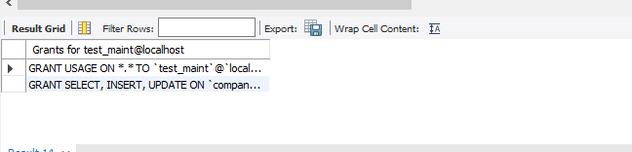
REVOKE ALL PRIVILEGES, GRANT OPTION FROM 'test_maint'@'localhost';
ALTER USER 'test_maint'@'localhost' ACCOUNT LOCK;

